Setting Up Your Virtual College Fair Booth

It’s a good idea to review this document in advance and prepare the elements you will be asked to supply. This is a sample of your final booth page. Each of these elements corresponds to a question on the registration form:

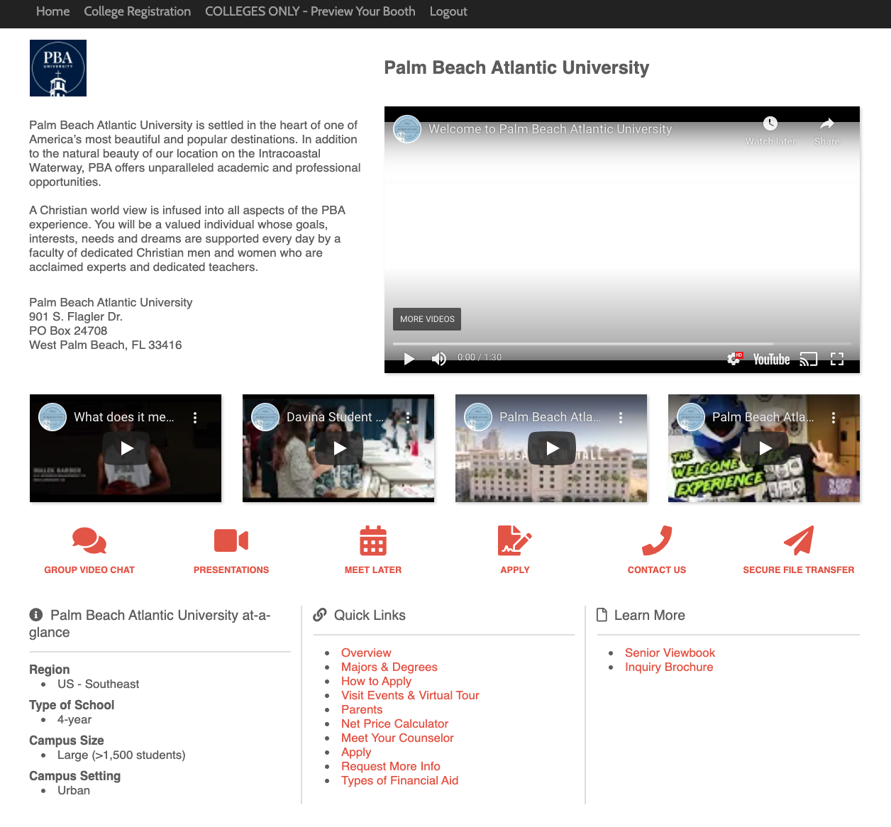

Let’s look more closely at the registration process and where the corresponding elements will appear on your booth.

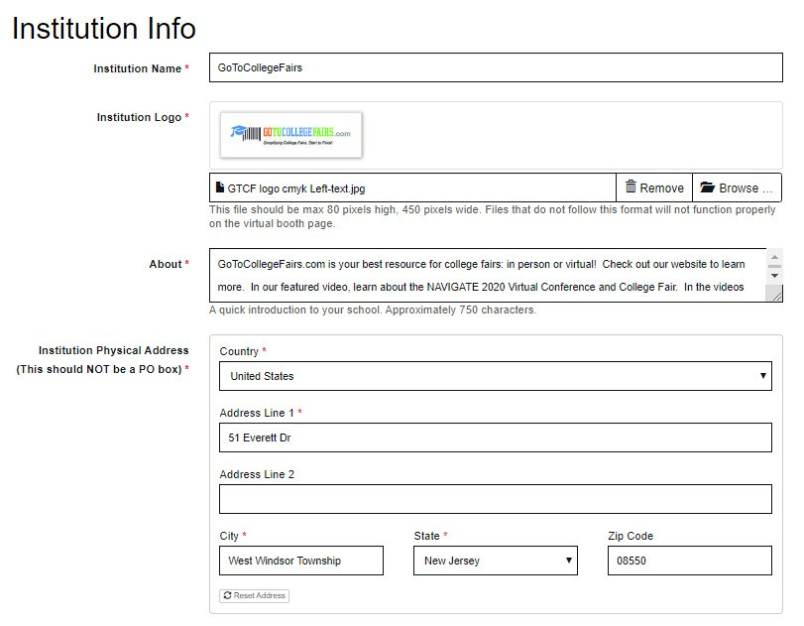

The information from this portion of the registration form will appear on your booth here:
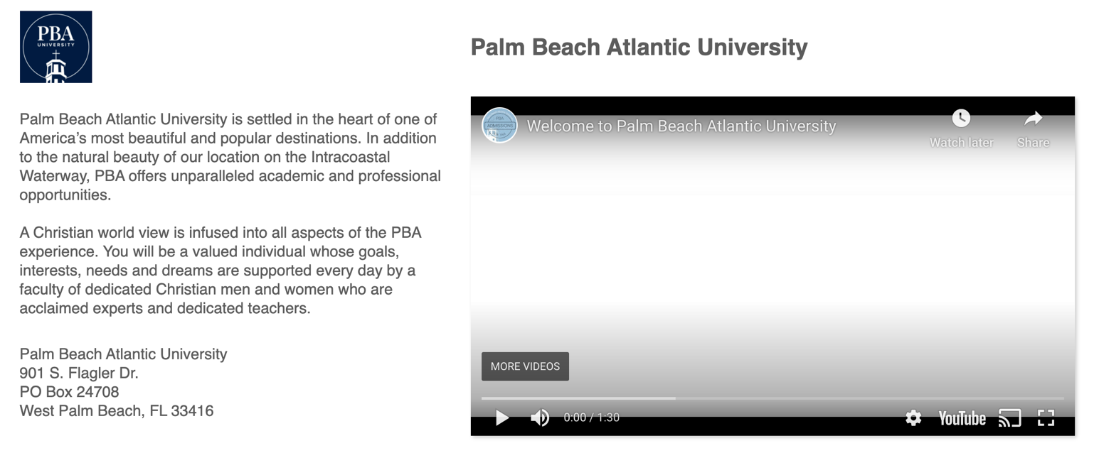
You will be asked to supply videos for attendees to view when they land on the booth. The ‘featured’ video will be larger and will automatically play when your booth page loads.

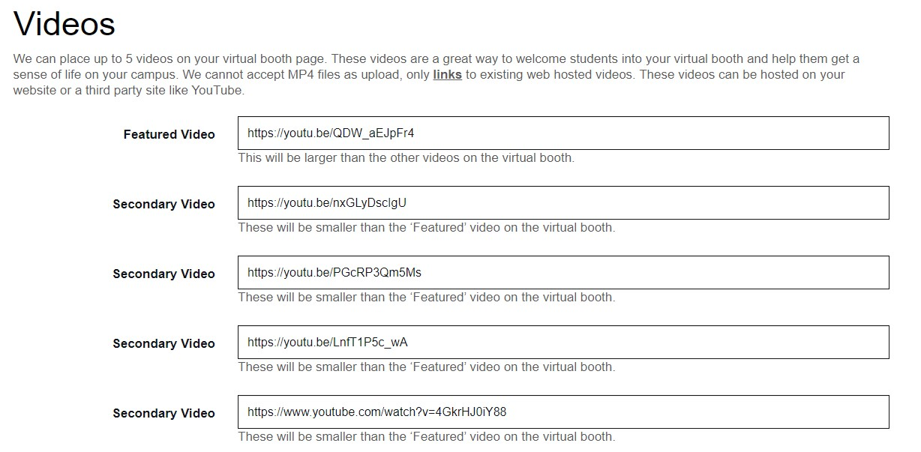

Videos will appear on your booth here:

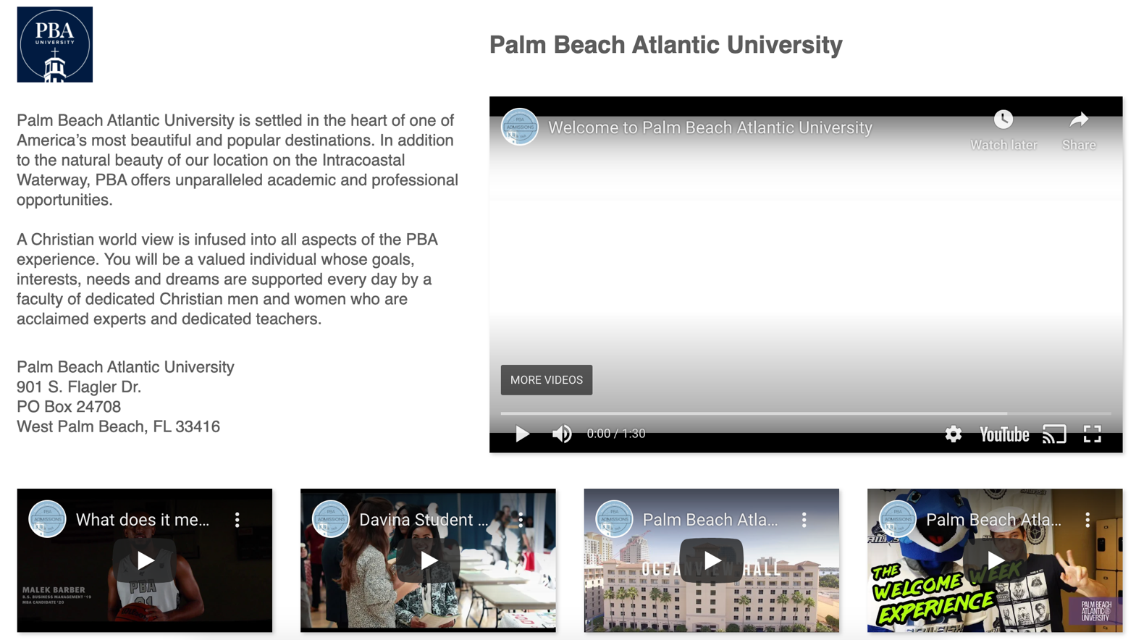
Secondary Videos
Featured Video

You will be asked to select ways that attendees can connect with you. You now have the option to video chat with students: Group Video Chat Link. Colleges should not use a generic room that might be in use on another date/time. Please use a unique link/room which is only open on the fair date and time.

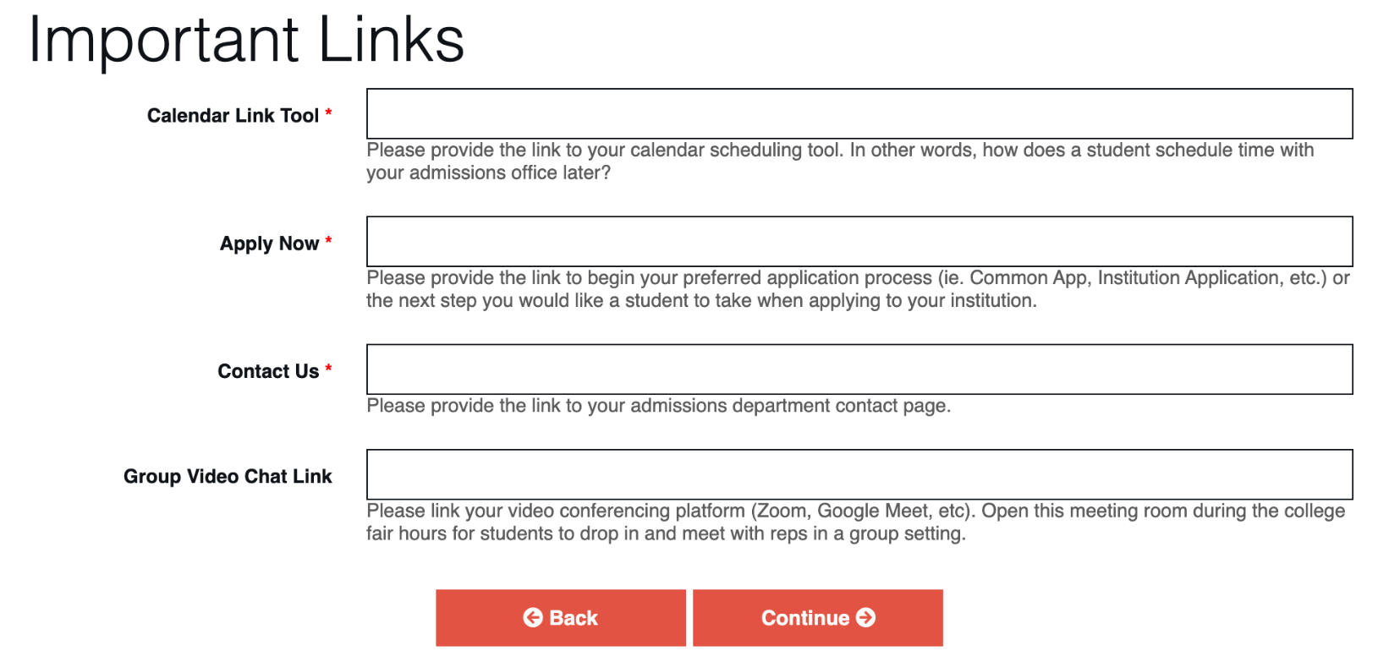

The calendar tool link, contact us, apply now, etc. listed above will be used to populate the following icons on your booth:

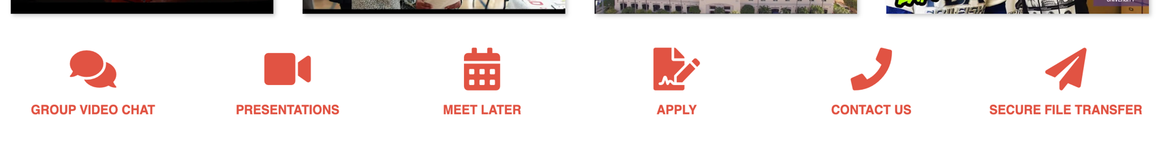

Secure File Transfer will allow students to pass your documents securely and quickly during the virtual college fair. This feature is fully integrated, no need for you to do anything. We recommend trying this feature at least once before the fair, so you understand it.

Your ‘presentation schedule’ is a very exciting element. This booth element allows you to present up to 10 titles/topics of your choosing. You pick the time that suits you. You may list a live presentation or a recording. If you choose to list a recording (YouTube, etc.), we recommend mentioning this is on-demand. If you choose to list a live presentation, use the video conferencing link that will host your presentation on the time/date you have indicated (zoom, etc.).

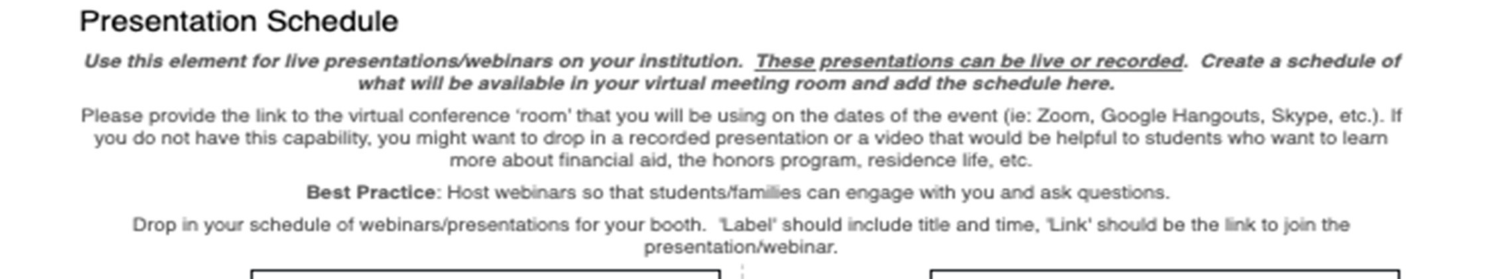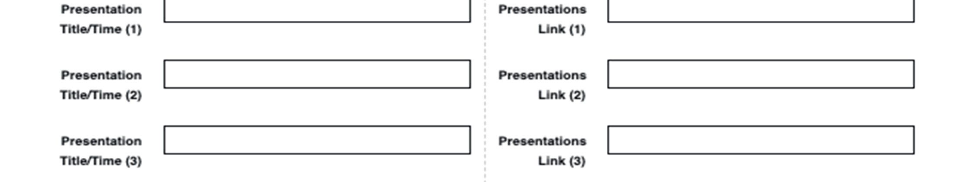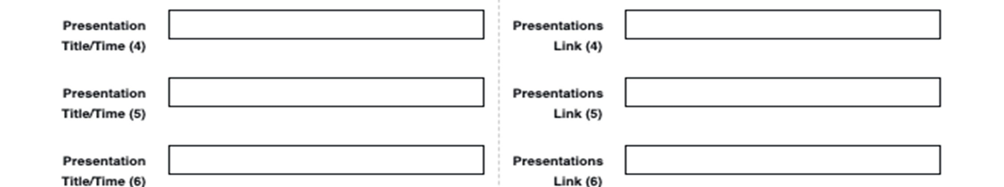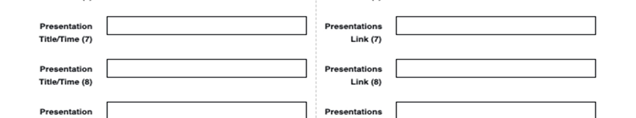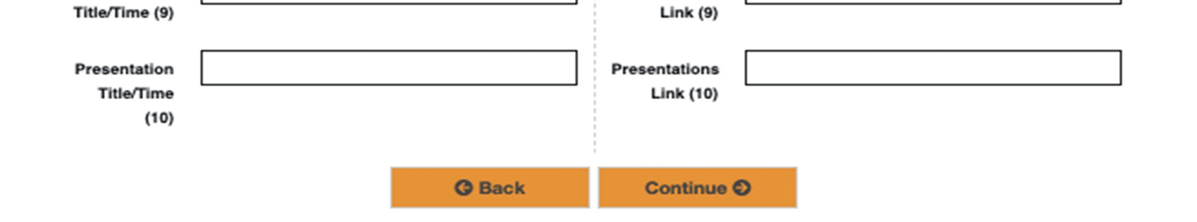

Your customized presentation schedule will appear on your booth here:

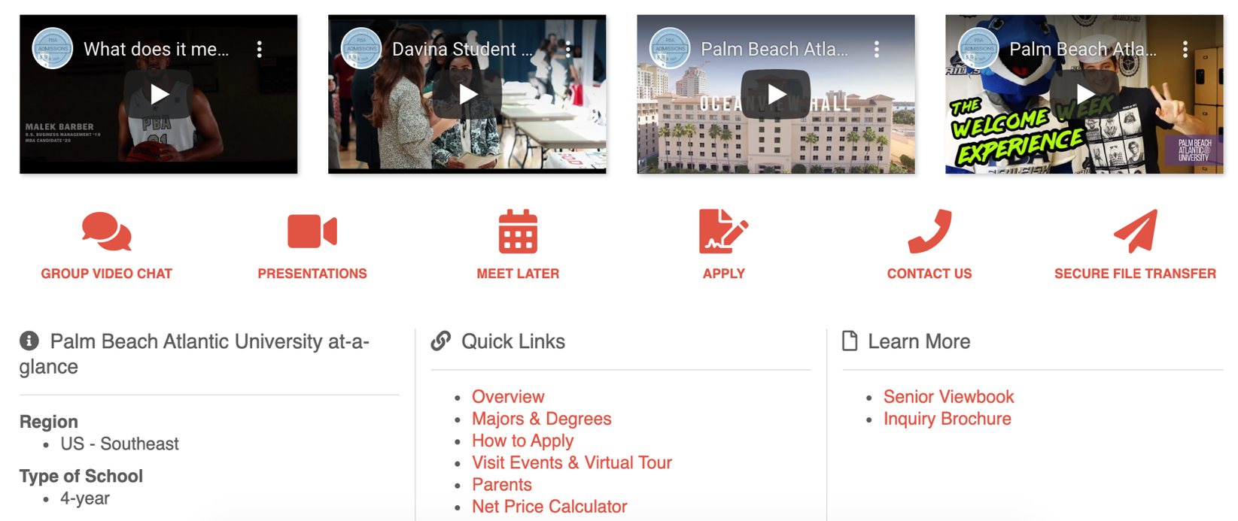

When a visitor clicks this ‘presentations’ icon, the customized schedule will appear as a pop-up window:

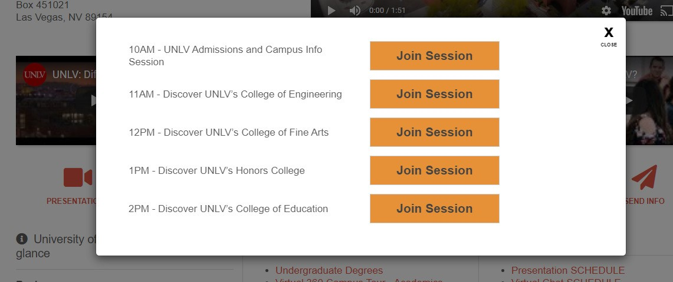

Quick Links will redirect to your institution’s website:
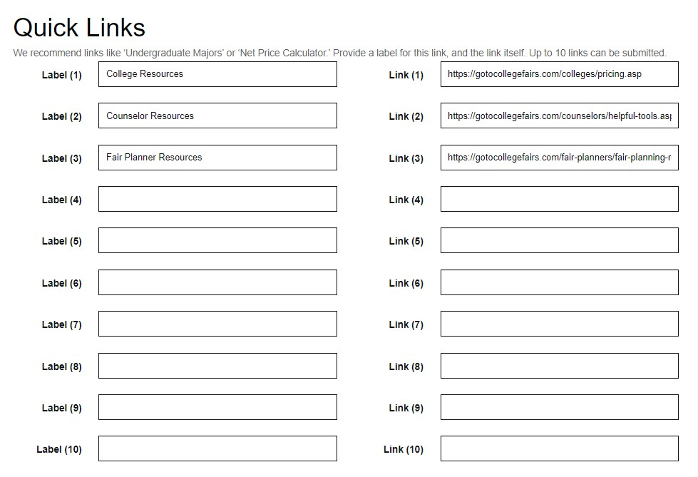

Quick Links appear on your booth here:

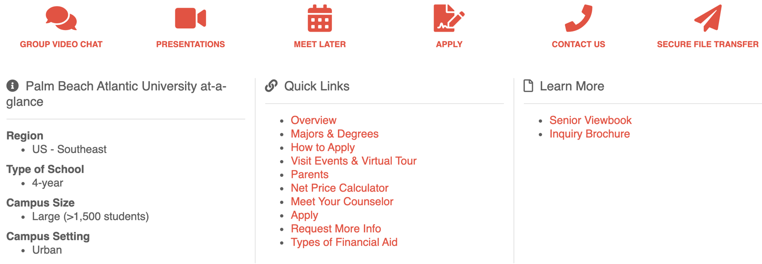

Documents can be loaded under ‘Learn More’ and will be hosted on the event site server for easy download by all visitors to your booth:

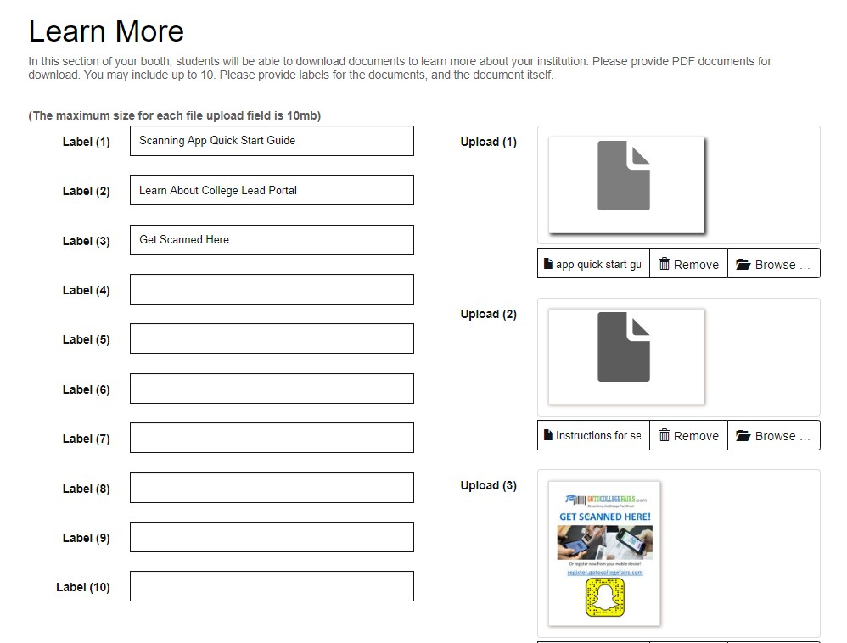

These documents appear on your booth here:

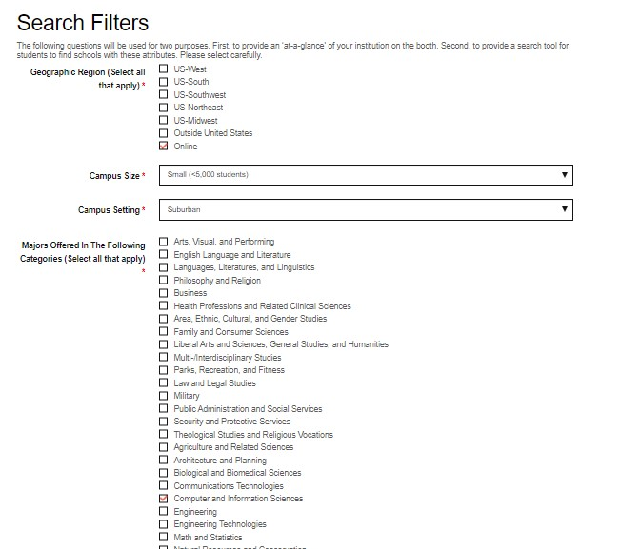

Search filters serve three purposes: first, students will answer a similar set of questions during the registration process and be matched with colleges that fit at least three selected attributes. These matches will be emailed to the student to help them plan for which booths to visit at the fair, and colleges will get this student data in their lead portal*. Second, as a way for students to find your school (there is a robust search filter for students to use in the virtual college fair), and third, in the ‘at-a-glance’ section of your virtual booth, here:
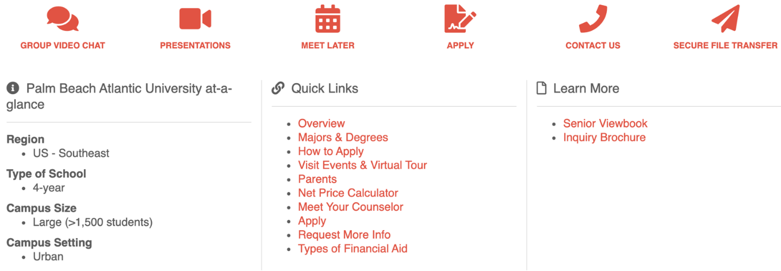

*this new data sharing is compliant with regulations protecting the handling of student data. We have updated our terms and conditions/privacy policy to reflect this data practice and students have the ability to opt out of this service if desired.

Leads will come to your GoToCollegeFairs Lead Portal in real time. The lead portal will not be set up until after college booth registration/booth build is closed. You can access this lead portal at www.gotocollegefairs.com.

If this event is charging for registration, you may be asked to include the Institution billing name and a phone number.
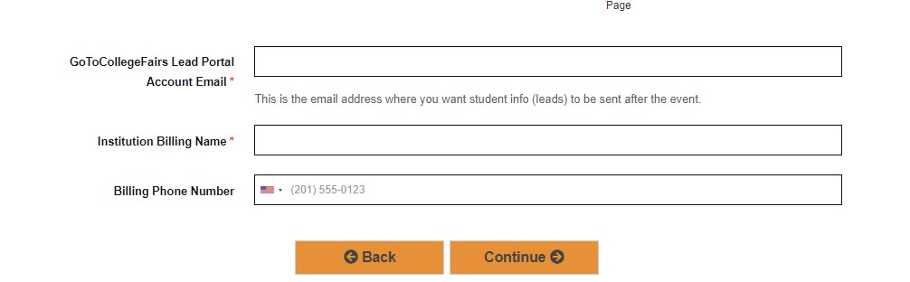

To preview your booth as attendees will see it, use the Preview Your Booth button on the home page of the website you registered on. Each website may appear slightly different, but all websites will have the button similar to the one pictured here:
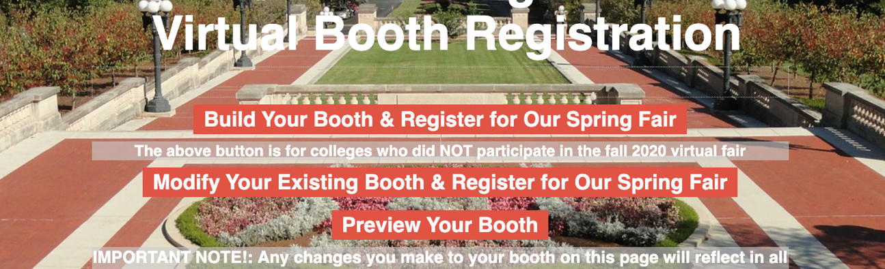

We hope this step-by-step was helpful. If you need assistance setting up your college booth, please contact your fair organizer.

